Celtic Guitar Treasures

A Folio of Memorable Arrangements of Irish, Scottish, and English Music for Solo Fingerstyle Guitar By El McMeen

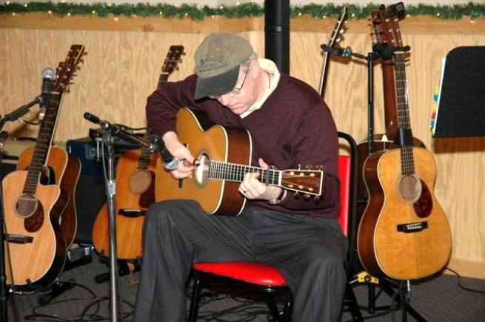

Including a Re-Mastered,
75-Minute Compact Disc of the
Original Recordings



PO Box 1028, Sparta, NJ 07871
Web: http://www.elmcmeen.com

(c),(p) 2005 El McMeen. All Rights Reserved.

